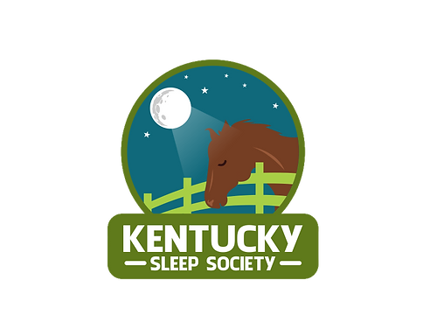

25th Annual Kentucky Sleep Society Conference
Location: | Louisville Marriott East 1903 Embassy Square Blvd. Louisville, KY 40299 | *All times are eastern  standard time*
Date: | November 3-4
Time: | 8:00 am Friday
Facilitator: | Kentucky Sleep Society

The goal of this conference is to provide a forum for interested providers to come together to review trends in sleep medicine and focus on future concepts. This conference is designed to meet a critical need expressed by regional sleep professionals to address the ever-changing field of sleep medicine. We welcome providers, technologists, therapists, and those interested in sleep medicine to attend our event. 15 hours of total CE content will be applied for CME, BRPT, and AARC.

Friday, November 3rd *Registration opens at 7am and closes at 7pm
TECHNICAL SESSION ----------------------------------------------------------------------------------------------------------------------------------
8:00am-9:00am Polysomnography Scoring Review
Dr. R. Reagan Gilley, Madisonville, KY
9:00am-10:00am Sleep Navigators and Post-Discharge Sleep Care to Reduce Readmissions
Robert Miller, RPSGT, RST, Rockwell, NC
*15-minute Break*
10:15am-11:15am Theories and Techniques of Behavior Change in Interventions for Sleep Apnea
Amber Carmen-Arroyo, PhD., Merced, CA

11:15am-12:15pm Medicare LCD Updates for Sleep Centers
Dru Watkins RPSGT, RRT, Oklahoma City, OK
12:15pm-1:15pm Lunch Buffet
1:15pm-2:15pm *Feature Presentation*
How to Create a Pediatric-Friendly Environment in the Sleep Center
Dr. Funke Afolabi-Brown, Philadelphia, PA
2:15pm-3:15pm Trends in Sleep Center Management
Brittany Myers MHA, RPSGT, RRT,CCSH, Lexington, KY
*15-minute Break* Network with Exhibitors
3:30pm-4:30pm Mandibular Advancement Device Therapy – An Overview
Glenn Blincoe DMD, Louisville, KY
4:30pm-5:30pm Sleep and Burnout Among Healthcare Professionals
Dr. R. Reagan Gilley, Madisonville, KY
Approval for 8 CEUs requested.
5:30pm-6:30pm Dinner Buffet
FRIDAY GENERAL SESSION ---------------------------------------------------------------------------------------------------------------------------------
6:30PM-7:30PM ICSD Scoring Updates and PAP Therapy Overview
Dr. Michael Zachek, Bowling Green, KY
7:30pm-8:30pm Medication Influences on Polysomnography and Artifact Recognition
Dr. Michael Zachek, Bowling Green, KY
8:30pm Adjourn for the day.
Approval for 2 CEUs requested.

Saturday, November 4 *Registration opens at 8am*
GENERAL SESSION----------------------------------------------------------------------------------------------------------------------------------------------
8AM-9AM *Continental Breakfast Buffet*
9:00-10:00 Surgical Treatment for OSA
Dr. Travis Shutt, Louisville, KY
10:00am-11:00am Neurodevelopmental Disorders and Pediatric Sleep
Dr. Emily Singer, Louisville, KY
*15-minute Break*
11:15am-12:15pm *Feature Presentation*
Alternative Treatments for Sleep Disordered Breathing in Children
Dr. Funke Afolabi-Brown, Philadelphia, PA
12:15pm-1:15pm Lunch Buffet
1:15pm-2:15pm Current and Future Diagnosis and Treatment of Narcolepsy
Dr. Kevin Trice, Louisville, KY
2:15pm-3:15pm Challenging Cases in Pediatric Sleep
Dr. Egambaram Senthilvel, Louisville, KY
3:15pm Closing Remarks – Jeremy T. Jones, KYSS Executive Director
Approval for 5 CEUs requested.

Continuing Education
Medicine, Physician Assistant, Nurse Practitioner: This course will be applied for a maximum of 15.00 AMA PRA Category 1 Credits. Physicians should claim only the credit commensurate with the extent of their participation in the activity.
All persons participating in continuing medical education programs accredited by the Southern AHEC are expected to disclose any or perceived conflict of interest related to the content of their presentations.
Dentistry: This program will be applied for approval for 15.00 hours.
Nursing: This program will be applied for 15.00 contact hours.
Respiratory Care: The American Association of Respiratory Care program application will be submitted for approval for up to a maximum of 15.00 CEs for the program. Participants should only claim those hours of credit actually spent in the educational activity.
Sleep Techs: CEC Program application will be applied for approval for up to a maximum of 15.00 CECs by the BRPT. Individuals must accurately and legibly complete all required provider documents. Participants should only claim those hours of credit spent in the educational activity.

Exhibitor opportunities: Exhibitors will receive a table in the exhibitor hall with power outlets and marketing on the KYSS social media platforms (Facebook and LinkedIn)
Manufacturer or Pharma Exhibitor DME
$1,000.00 $500.00
Become a Member of the KYSS and Save on Registration Costs!!
Join online at www.kyss.org, at the KYSS table, or scan this QR
Code:
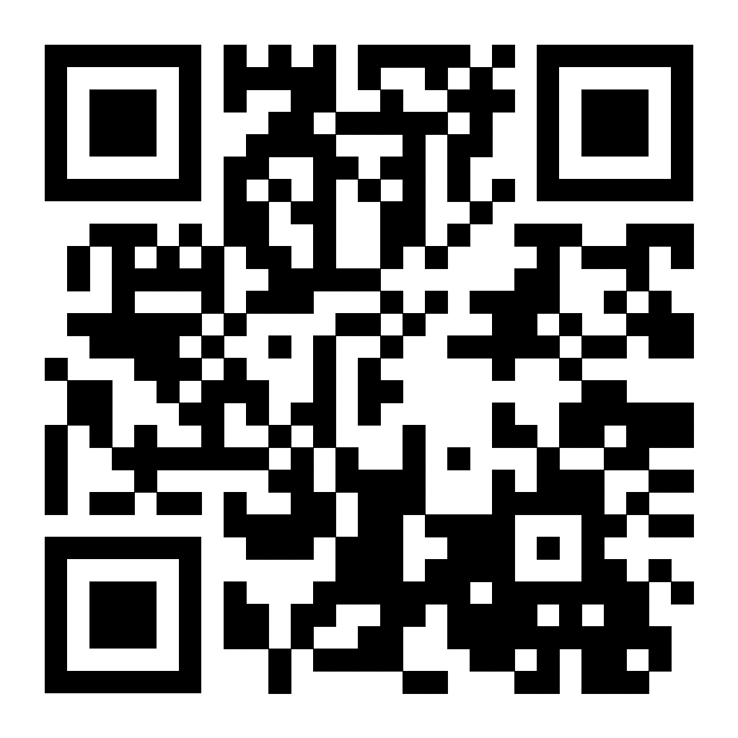

Registration
(Meals are included in all prices)
Tech Course Only:
Non-Member: $145.00 before September 30; $165.00 after September 30
Member: $120.00 before September 30; $140.00 after September 30
Friday General Session Only
Non-Member: $90.00 before September 30; $115.00 after September 30
Member: $85.00 before September 30; $105.00 after September 30
Technical Course and Friday General Session:
Non-Member: $235.00 before September 30; 280.00 after September 30
Member: $205.00 before September 30; $245.00 after September 30
Saturday General Session Only
Non-Member: $150.00 before September 30; $170.00 after September 30
Member: $130.00 before September 30; $150.00 after September 30
Friday and Saturday General Sessions
Non-Member: $200.00 before September 30; $220.00 after September 30
Member: $180.00 before September 30; $200.00 after September 30
Entire Conference
Non-member: $280.00 before September 30; $310.00 after September 30
Member: $250.00 before September 30; $280.00 after September 30

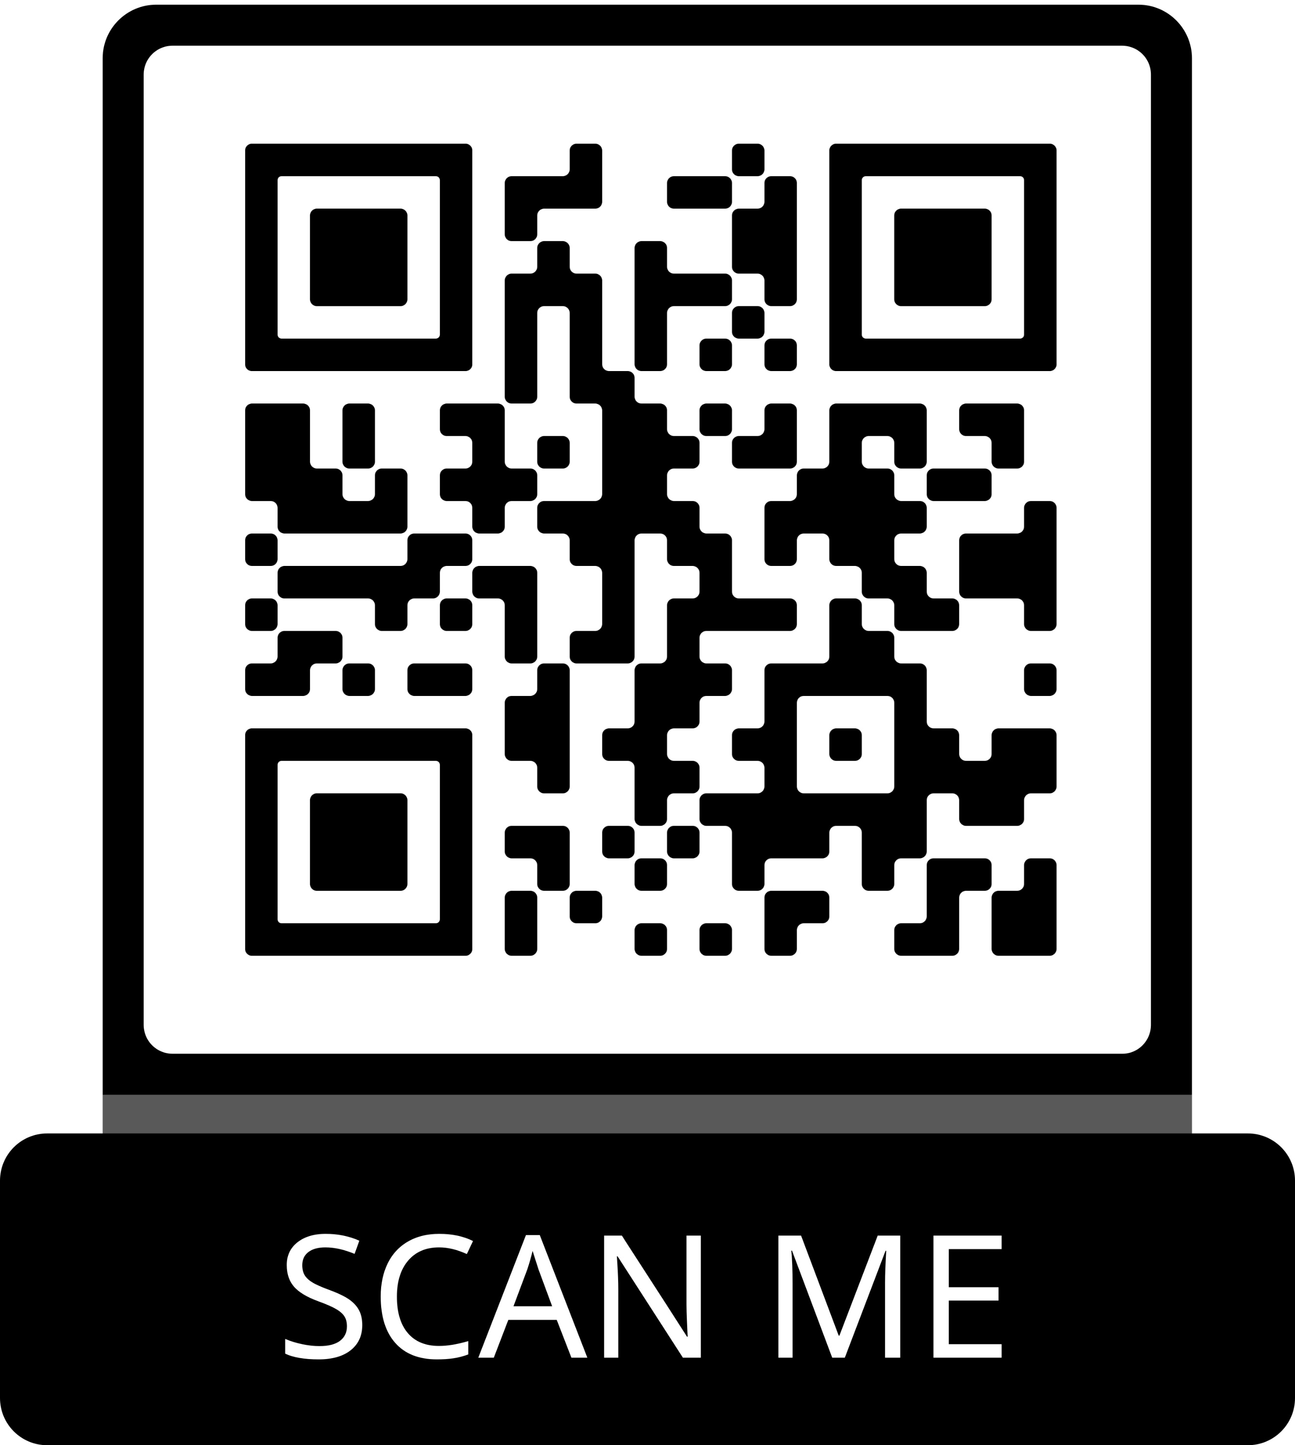
Register online here
Or by scanning this QR code:

To register by paper circle or check beside your attendance level and mail payment to:
Kentucky Sleep Society 61 Shayla Ct. Rineyville, KY 40162

Hotel Reservation Information

Click here to reserve your room for the 25th Annual KYSS Conference
Or
Call the Louisville Marriott East @
502-491-1184
Be sure to mention the Kentucky Sleep Society when booking to receive discounted rate

